**PHASE-4 THIRD PROJECT WRITEUP**

**myPortfolio: Easy Way to Create Your Amazing Portfolio.**

DESCRIPTION

**Project Objective:**

As a Full Stack Developer, you have to create a frontend for the myPortfolio application.

**Background of the problem statement:**

In the third sprint, the scrum team agreed to develop the frontend of the application using an Angular framework. Since you were recently trained in working on this framework, you’re chosen to lead this project and complete the initial part of the application. You agree to complete this task as early as possible, as the release of the application is next week.

**You must use the following:**

● Angular: To develop a front-end application that includes a sign up page, a sign in page, and a landing page   
● Git: To connect and push files from the local system to GitHub   
● GitHub: To store the Angular application

In this project we develop a front-end application that includes a sign up page, a sign in page, and a landing page using angular.

Creating a new project

.

* Angular has been installed in your practice labs using npm (Refer FSD: Lab Guide - Phase 4)
* To verify the installation:
  + Open the command-line interface
  + Type in the command:

*ng --version*

* Create a new project using the command:

*ng new angular-app*

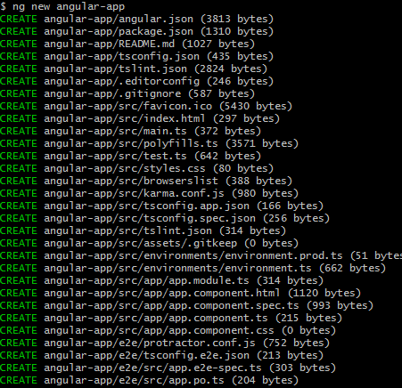

* Move the code to the application folder and start the server.

*cd angular-app*

*ng serve -o*

Creating Angular components

* Open Visual Studio Code
* Navigate to the created portifolio project folder.

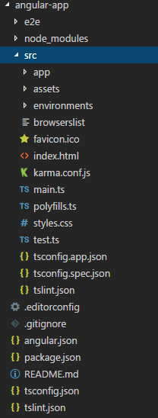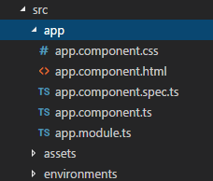

* Add the following code in *app.module.ts*.

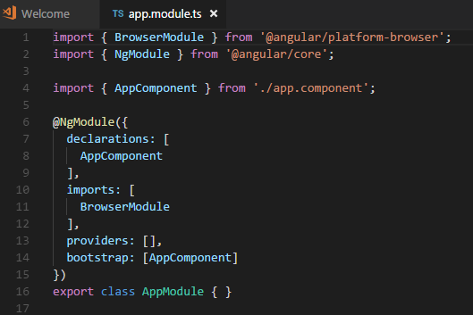

What is a portfolio

The portfolio can have the same purpose as a CV. Most CVs are written with text, while the portfolio is for showcasing, so it is visual with images and often more detailed than the CV.

It is a place where you can show your work experience and showcase the projects that you are most proud of.

Your online portfolio can be shared with its link to companies, hiring managers, and recruiters, so that they can notice you.

It is about showing and giving others an understanding of who you are as a professional.

Why create a portfolio

It is a great way of growing your online presence and get noticed.

It can be used to get a job or to attract clients to your services.

Having it online as a website. Makes it possible for people all over the world to find you.

The design of the portfolio will give the reader an impression of who you are. Make sure that it appears in a good and presentable way!

## Who is a portfolio for

Creating a portfolio can be important for your career.

It can be helpful when searching for a job, a freelancing gig, or showcasing your skills towards a new client.

Typical roles that use portfolios are professionals such as, but no limited to:

* Software developers
* UX designers
* Graphic designers
* Photographers
* Marketing professionals
* Architects
* Writers

## What are the most important sections in a portfolio

There are many different ways of creating a portfolio.

How to create it depends on what type of professional you are, who you are building it for, and why you are creating it.

You have to **test, fail and learn** to find out which type of portfolio that is right for you!

**1.Home section.**

The home section is the first thing people see when they enter your portfolio.

It is displayed under your logo and menu.

The hero section helps the reader to understand what you offer, why someone should work with you, and the value that you provide with your services.

It often contains a call-to-action button like "contact me", "book a meeting" or similar.

**2. About me section.**

Give the reader a short summary about yourself.

Include subjects such as your education, work experience, projects and interests.

Help the reader to understand what you are passionate about and your superpowers (the things that you are really good at).

Remember to keep it short and simple.

**3. Projects section.**

List the projects that you have worked on. The most used way is to order the list by date, but in some cases, it can make sense to order them in another logical way.

Add details to each project, which includes your role, what you did, and, how the project turned out.

Adding pictures to showcase what you built is a plus! Showcase the things that you are proud of.

**4. Contact me section**.

Let the reader know how and where they can get in touch with you.

Add your contact details and other contact channels such as your GitHub profile, LinkedIn, YouTube and so on.

**Conclusion:**

Developed a front-end application that includes a sign up page, a sign in page, and a landing page using angular.

Git: To connect and push files from the local system to GitHub   
GitHub: To store the Angular application

**Pushing the code to your GitHub repositories:**

* Open your command prompt and navigate to the folder where you have created your files.

**cd <folder path>**

* Initialize your repository using the following command:

**git init**

* Add all the files to your git repository using the following command:

**git add .**

* Commit the changes using the following command:

**git commit . -m “Changes have been committed.”**

* Push the files to the folder you initially created using the following command:

**git push -u origin master**